# Project Documentation Phase 6

Event Management & Ticketing System on Salesforce

## Phase 6: User Interface Development – Event Management & Ticketing System

### 🔹 Objective

This phase focuses on designing and building the **User Interface (UI)** for the *Event Management & Ticketing System*. The goal is to provide an interactive, responsive, and user-friendly experience for **Event Organizers, Attendees, and Admins** using Salesforce Lightning Experience features and Lightning Web Components (LWC).

**Step 1: Create the Lightning App (Event Manager)**

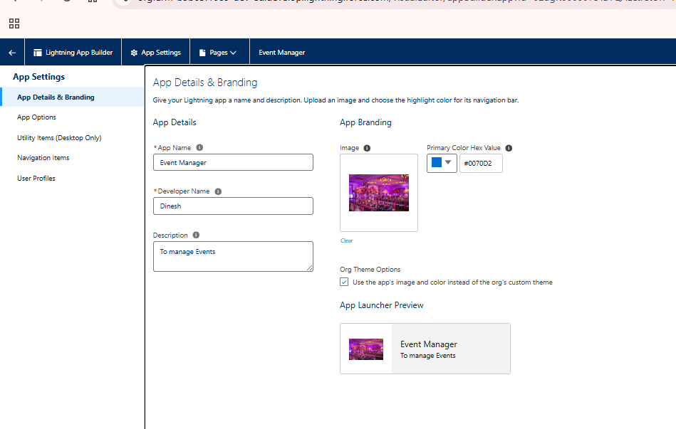

Setup → App Manager → New Lightning App.

Name: Event Manager.

Add Tabs:

Events (Event__c)

Tickets (Ticket__c)

Attendees (Attendee__c)

Feedback (Feedback__c)

Reports

Dashboards

Assign to Organizer/Admin profiles. :- This gives you a single workspace with all objects + analytics.

**Step 2: Simple Flows for Data Entry**

You don’t need complex logic — just Screen Flows to insert records and show “Success” screen.

**A) Event Creation Flow**

Flow Type: Screen Flow

Screen: Enter fields → Event Name, Start Date, End Date, Venue, Capacity, Status.

Create Records → Event__c.

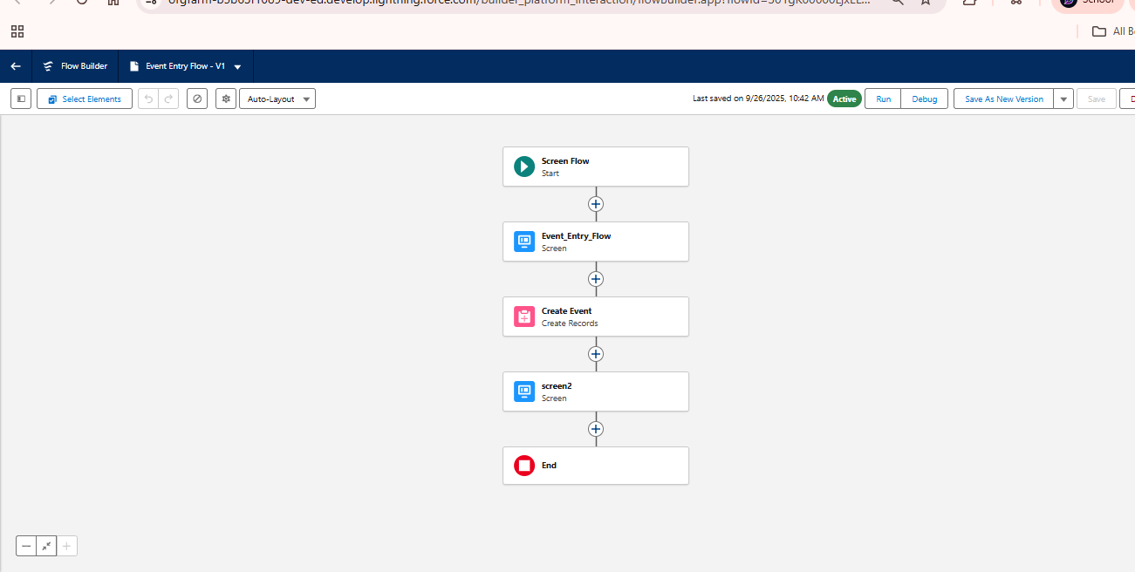

Screen → “✅ Event created successfully.”

👉 Save as Event_Entry_Flow.

**B) Attendee Registration Flow**

Screen: Name, Email, Phone, Check-In Status.

Create Records → Attendee__c.

Screen → “✅ Attendee registered.”

👉 Save as Attendee_Entry_Flow.

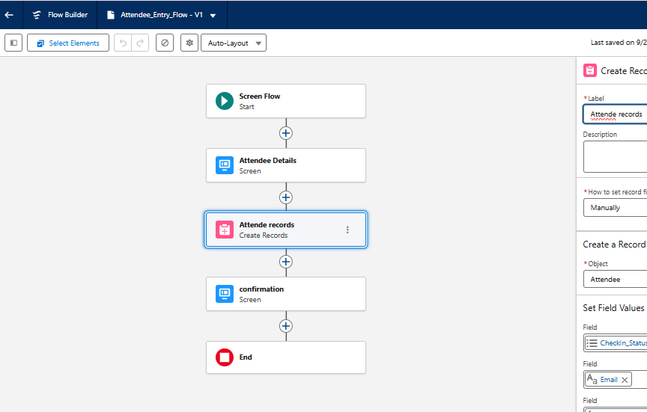

C) Ticket Issuing Flow

Screen: Select Event (Lookup), Attendee (Lookup), Ticket Type, Status, Price.

Create Records → Ticket__c.

Screen → “✅ Ticket issued successfully.”

👉 Save as Ticket_Issuing_Flow.

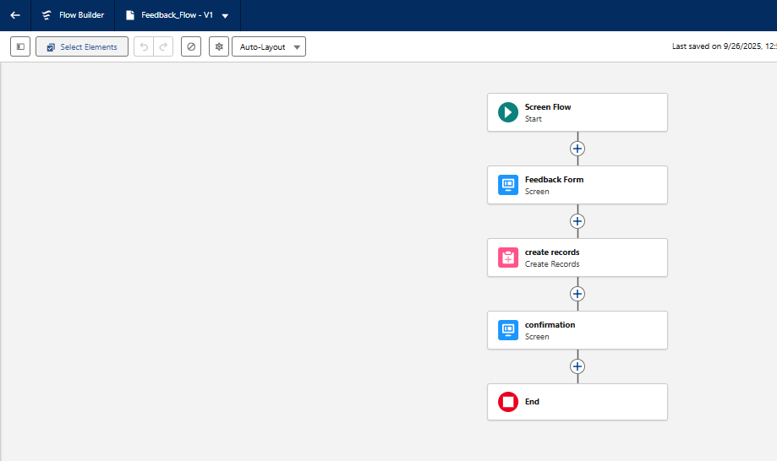

D) Feedback Capture Flow

Screen: Select Event (Lookup), Attendee (Lookup), Rating, Comments.

Create Records → Feedback__c.

Screen → “✅ Feedback submitted.”

👉 Save as Feedback_Flow.

👉 Add these Flows to Lightning Pages or App Tabs so staff can quickly enter data.

